**CODE:-**

// Vector Sequence Container

#include <iostream>

#include <vector>

using namespace std;

void display(vector<int> &); // display function prototype

int main()

{

vector<int> v; // integer vector created

cout << "\n\nInitial size() = " << v.size(); // gives no of elements

cout << "\n\nInitial capacity() = " << v.capacity(); // capacity returns no elements that vector can store b4 that vector needs to dynamically resize itself to accommodate more elements

v.push_back(10); // pushing the element at back of vector

v.push_back(20);

v.push_back(30);

v.push_back(40);

v.push_back(50);

cout << "\n\nAfter push_back() size() = " << v.size();

cout << "\n\nAfter push_back() capacity() = " << v.capacity();

cout << "\n\nDisplay vector elements after push_back() :";

display(v);

cout << "\n\nFrist element of vector = " << v.front();

cout << "\n\nLast element of vector = " << v.back();

// Inserting elements in vector using iterator

vector<int>::iterator itr = v.begin(); // here itr is pointing to 0th element of v

itr = itr + 5; // itr made to point 4th element;

v.insert(itr, 60); // insert 40 as 4th element of v

cout << "\n\nDisplay vector elements after insertion :";

display(v);

// pop_back() function to delete last element

v.pop_back();

cout << "\n\nDisplay vector elements after pop_back() :";

display(v);

// erase(delete) vector elements

v.erase(v.begin() + 2, v.begin() + 4); // erase(2,4) = deletes 30 & 40 but not 50

cout << "\n\nDisplay vector elements after erase() :";

display(v);

// resizing vector

v.resize(10);

cout << "\n\nAfter resize() vector size = " << v.size();

// using clear function

v.clear();

cout << "\n\nAfter clear() function :";

display(v);

cout << "\n\nIs vector empty = " << v.empty();

getchar();

return 0;

}

void display(vector<int> &v)

{

for (int i = 0; i < v.size(); i++)

{

cout << " " << v.at(i); // at() prints vector element at each reference index

}

}

**OUTPUT:-**

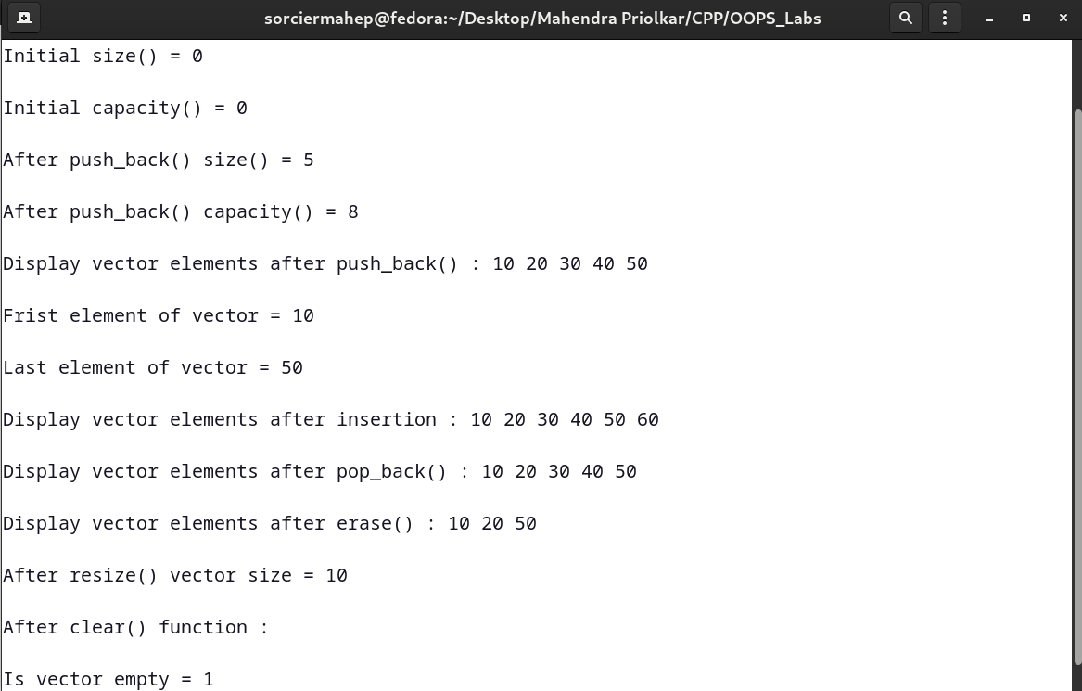

**CODE:-**

// List sequence Container

#include <iostream>

#include <list> //linear linked list

using namespace std;

void display(list<int> &); // display function prototype

int main()

{

list<int> list1; // empty list1 of zero length

list<int> list2; // empty list2

list<int> list3;

cout << "\n\nsize of list1 = " << list1.size();

list1.push_front(2);

list1.push_front(1);

list1.push_back(3);

list1.push_back(4); // 1234

cout << "\n\nList1 elements after push_front() and push_back() :";

display(list1);

// Remove an element from front end

list1.pop_front(); // same way pop_back()

cout << "\n\nAfter removing front element of list1 : ";

display(list1); // 234

// insert an element(1) at the begining of list1

list1.insert(list1.begin(), 1);

cout << "\n\nAfter inserting an element at begining of list1 : ";

display(list1); // 1234

// pushing elements in list2

list2.push_front(5);

list2.push_front(6);

list2.push_back(9);

list2.push_back(8);

list2.push_back(7); // 65987

cout << "\n\nList2 elements after push_front() and push_back() :";

display(list2);

// sorting list2 elements

list2.sort();

cout << "\n\nList2 elements after sorting :";

display(list2); // 56789

// splice(insert) the elements of list2 at the end of list1

list1.splice(list1.end(), list2); // similarly splice could be at begin() also

cout << "\n\nList1 elements after splicing :";

display(list1); // 123456789

// merging list1 contents into list3

list3.merge(list1);

cout << "\n\nList3 elements after merging :";

display(list3);

// reverse a list

list3.reverse();

cout << "\n\nList3 elements after reversing :";

display(list3);

list3.push_back(9);

list3.push_back(9);

cout << "\n\nUpdated list3 elements :";

display(list3);

// Removing duplicates from list3 elements

list3.unique();

cout << "\n\nAfter removing duplicates from list3 elements are :";

display(list3);

// remove all 9's from list3

list3.remove(9);

cout << "\n\nAfter removing all 9's from list3 elements :";

display(list3);

// using swap() function

list2.swap(list3);

cout << "\n\nAfter swapping list2 : ";

display(list2);

cout << "\n\nAfter swapping list3 : ";

display(list3);

// Using assign() function

list3.assign(list2.begin(), list2.end());

cout << "\n\nAfter assiging list2 elements to list3 :";

display(list3);

getchar();

return 0;

}

void display(list<int> &v)

{

list<int>::iterator p;

for (p = v.begin(); p != v.end(); ++p)

cout << " " << *p;

}

**OUTPUT:-**

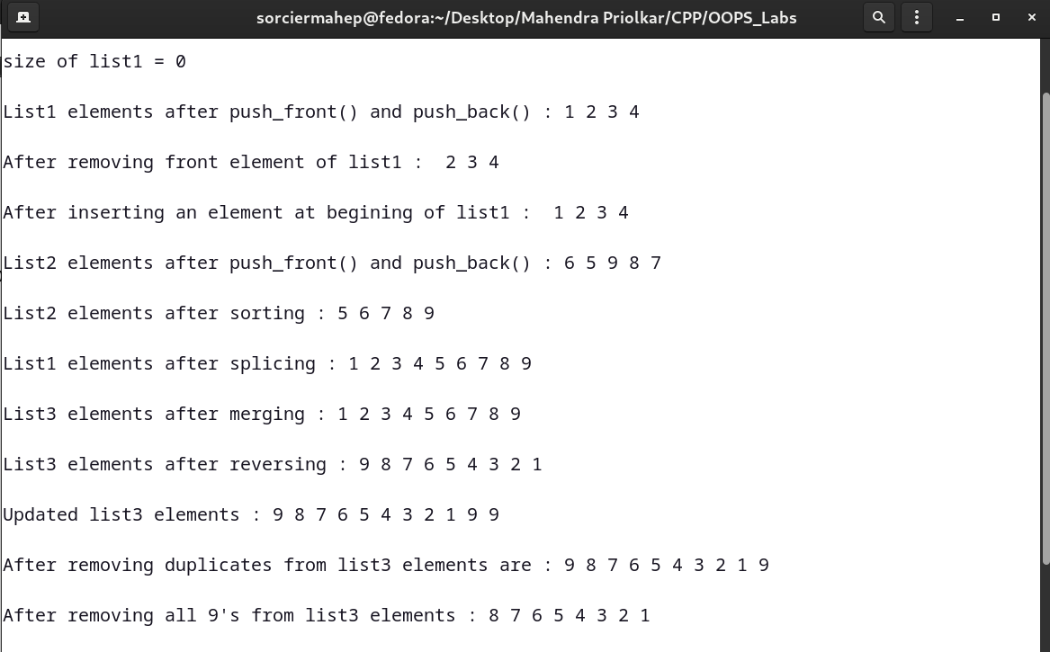

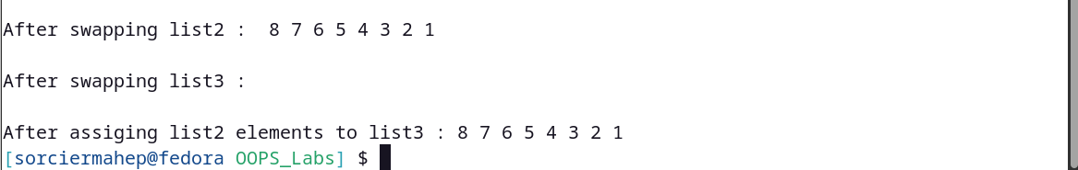

**CODE:-**

// Dequeu Sequence Container

#include <iostream>

#include <deque>

using namespace std;

void display(deque<double> &); // display function prototype

int main()

{

deque<double> d;

// insert elements in d

d.push_front(2.2);

d.push_front(3.5);

d.push_back(1.1); // 3.5 2.2 1.1

cout << "\n\nDeque elements after insertion are as follows :";

display(d);

// pop_front() to remove front element

d.pop_front(); // d.pop_back();

cout << "\n\nDeque elements after pop_front() are as follows :";

display(d);

// using [] subsricpt operator to modify elements

d[1] = 3.3; // 1.1 gets overwritten by 3.3

cout << "\n\nDeque elements after subscript insertion using [] are as follows :";

display(d);

getchar();

return 0;

}

void display(deque<double> &d1)

{

for (int i = 0; i < d1.size(); i++)

{

cout << " " << d1[i];

}

}

**OUTPUT:-**

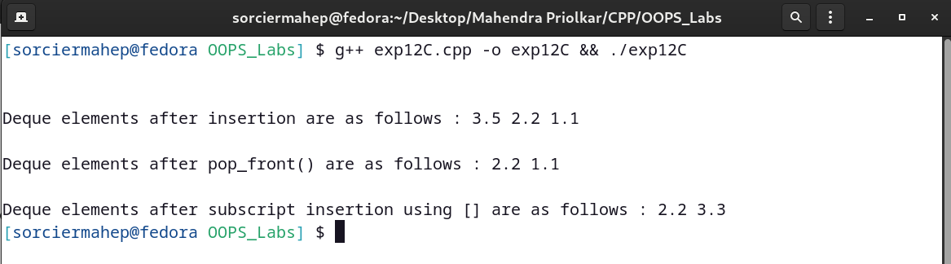

**CODE:-**

// Standard Library stack adapter class {can be implemented as vector,deque,list}

#include <iostream>

#include <vector>

#include <list>

#include <deque>

#include <stack>

using namespace std;

template <class T>

void pushelement(T &s); // pushelement() function prototype

template <class T>

void popelement(T &s); // popelement() function prototype

int main()

{

stack<int> dequestack; // stack with default underlying deque

stack<int, vector<int>> vectorstack; // stack with underlying int vector

stack<int, list<int>> liststack; // stack with underlying int list

// push 10 elements on each of these stacks (i.e dequestack,vectorstack,liststack)

cout << "\n\npushing elements onto dequestack : ";

pushelement(dequestack);

cout << "\n\npushing elements onto vectorstack : ";

pushelement(vectorstack);

cout << "\n\npushing elements onto liststack : ";

pushelement(liststack);

cout << "\n\n------------------------------------------------";

cout << "\n\npopping element from dequestack : ";

popelement(dequestack);

cout << "\n\npopping element from vectorstack : ";

popelement(vectorstack);

cout << "\n\npopping element from liststack : ";

popelement(liststack);

getchar();

return 0;

}

// Function definition for pushelement()

template <class T>

void pushelement(T &s)

{

for (int i = 0; i < 10; i++)

{

s.push(i);

cout << s.top() << " ";

}

}

// Function definition for popelement()

template <class T>

void popelement(T &s)

{

while (!s.empty())

{

cout << s.top() << " ";

s.pop();

}

}

**OUTPUT:-**

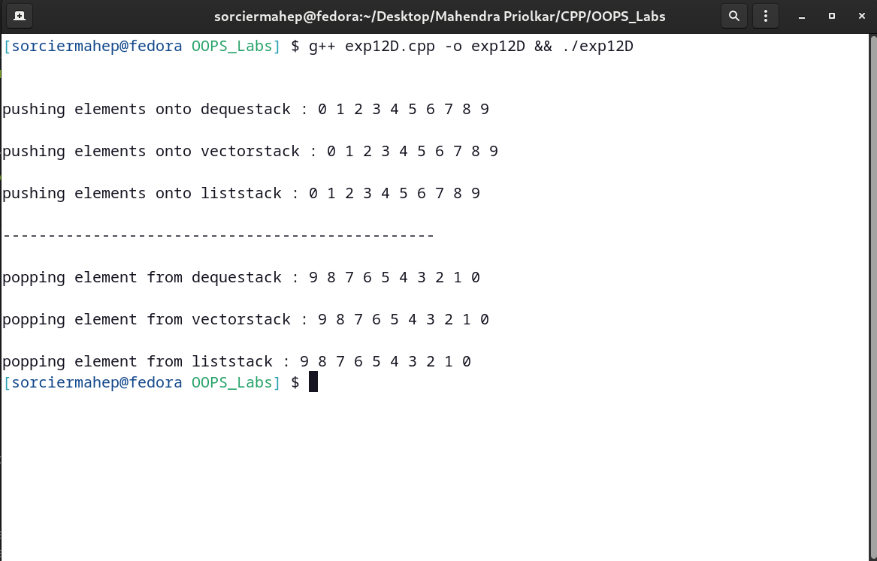

**CODE:-**

// Standard Library queue adapter class

#include <iostream>

#include <queue>

using namespace std;

int main()

{

queue<double> q; // double type queue "q" created (initially empty)

// push elements onto queue

q.push(1.1); // 1.1 2.2 3.3

q.push(2.2);

q.push(3.3);

cout << "\n\nPopping elements from queue : ";

while (!q.empty())

{

cout << q.front() << " ";

q.pop();

}

getchar();

return 0;

}

**OUTPUT:-**

